Security Groups.

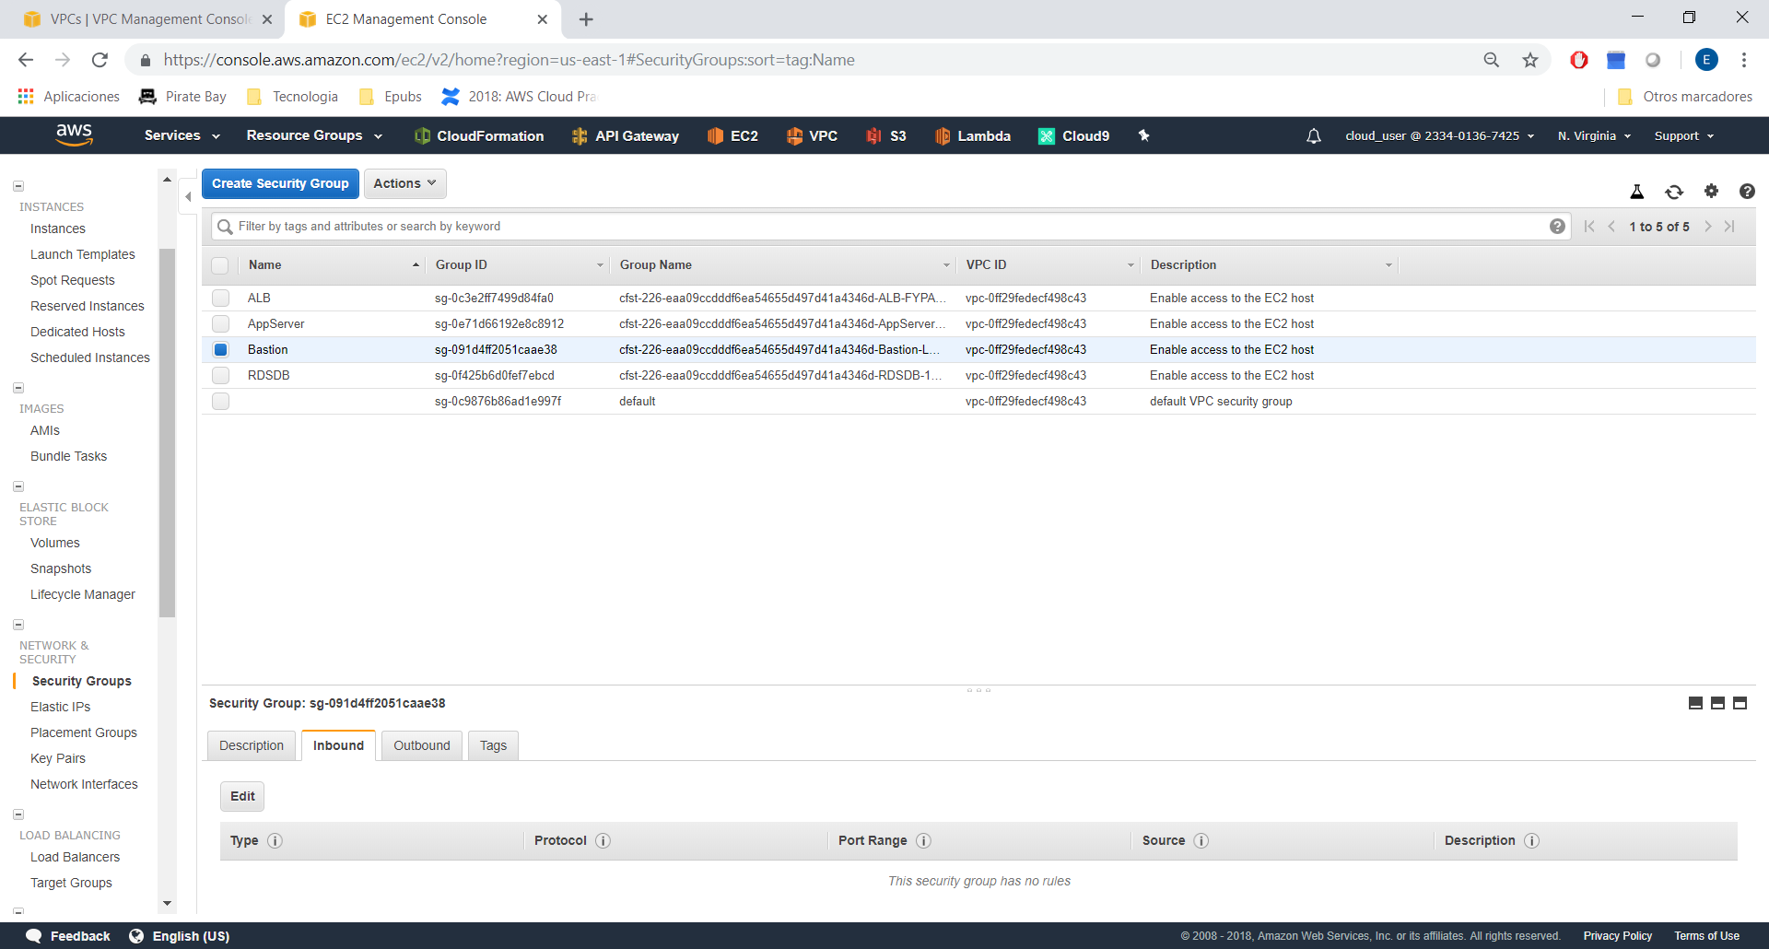

Add rule to Bastion.

SSH → port 22 to 0.0.0.0/0

For ALB:

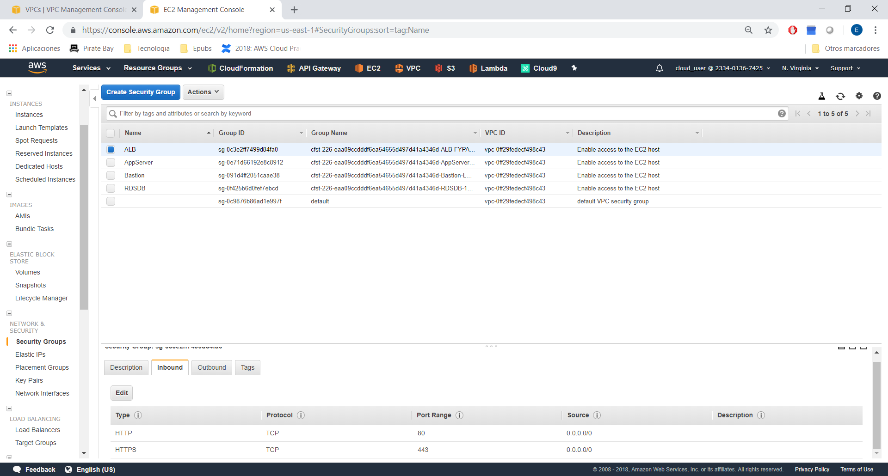

Moving to Application Server.

1) Give access HTTP to ALB

2) Give access SSH from bastion

